Testrail test cases snapshot

Testrail execution snapshots

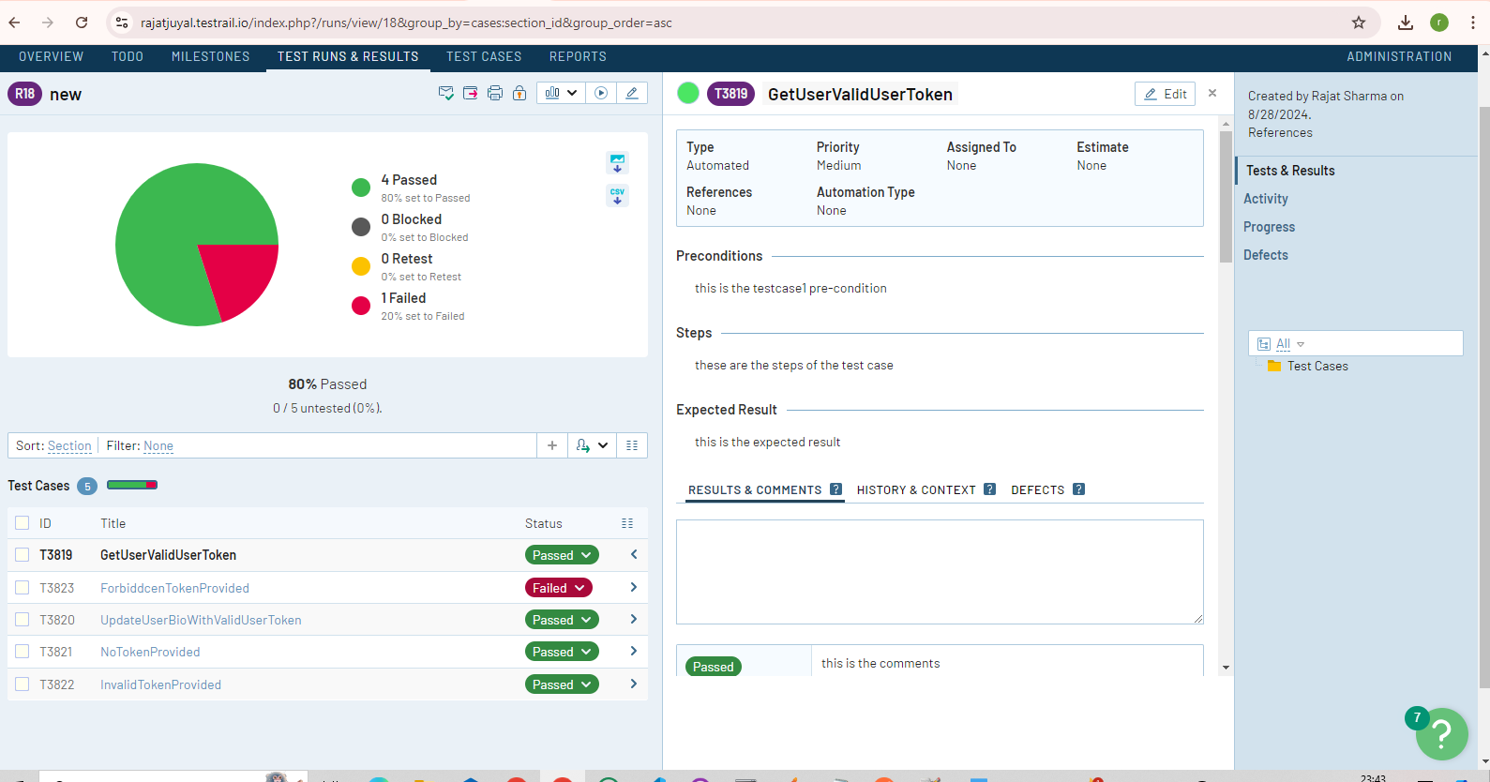

1 test case/script is failing as 403 forbidden response is not appearing for a github token that does not have any permission assigned. 401 appears in that case too.